**The Excretory System**

* Outline the role of the excretory system.   
  The excretory system is a bodily system responsible for excess/unnecessary materials from the body to help maintain balance and to prevent damage. This system handles the elimination of metabolic waste products and other liquid and gaseous wastes (through urine, sweat, exhalation). The blood volume of the entire body is filtered 60-70 times per day.
* Contrast excretion and egestion.   
  Excretion is a process unique to the excretory system, whereas the process of egestion only occurs in the digestive system.

**Organs of the Excretory System**

* List the organs involved in excretion.   
  The organs that are involved in excretion include the lungs, skin, liver, and kidneys.
* Name the key waste product/s excreted from each organ.   
  The lungs of the respiratory system excrete carbon dioxide and water as waste products.  
  The skin excretes wastes such as water through the sweat glands.  
  The liver excretes bile pigments that result from the destruction of haemoglobin. It also converts nitrogenous waste from the breakdown of proteins into urea.  
  The kidneys excrete excess water as well as urea.

**Nitrogenous Wastes**

* Explain how nitrogenous wastes are formed.   
  Most of our nitrogenous waste comes from the breakdown of amino acids. This occurs by deamination. Deamination of amino acids results in the production of ammonia (NH3)
* Explain why ammonia must be removed from the body quickly.   
  Ammonia is an extremely toxic base and its accumulation in the body would quickly be fatal.
* Explain how the liver creates urea.  
  The liver contains a system of carrier molecules and enzymes which quickly convert the ammonia (and carbon dioxide) into urea (called the urea cycle). One turn of the cycle consumes 2 molecules of ammonia and 1 molecule of carbon dioxide to create 1 molecule of urea.

**Parts of the Kidney**

* Draw a diagram showing the parts of the kidney.   
  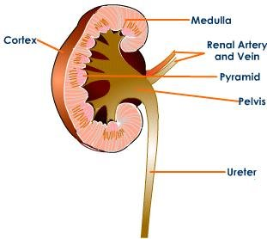
* Outline the role of each part of the kidney.   
  The cortex is where the blood is filtered, and it has nephrons for filtration.  
  The medulla contains the connecting ducts which carry filtrate (filtered substances) to the pelvis.  
  The pelvis is the meeting point of the collecting tubules.

**Nephron Function**

* Explain the function of each part of the nephron.  
  Water and most solutes (glucose, AA, fatty acid, vitamins, minerals, salt) blood plasma are filtered from the glomerulus and into the Bowman’s Capsule.  
  All glucose, some water, amino acids, and fatty acids are reabsorbed (diffused) into blood in the Proximal Convoluted Tubule.  
  Salt diffuses into the blood in the Loop of Henle.  
  Water is reabsorbed in the Distal Convoluted Tubule.  
  Collecting duct collects filtrate and concentrates into urine. Urine moves to pelvis of kidney, ureter, bladder, urethra.